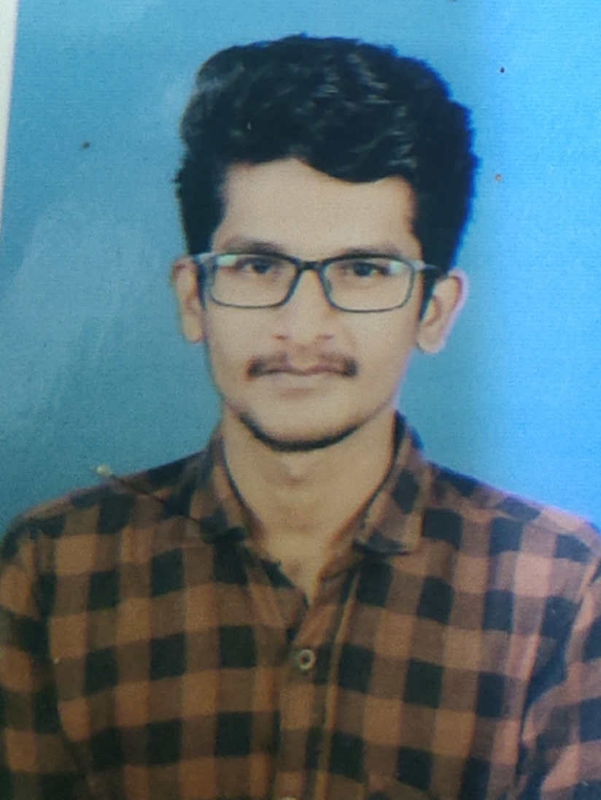

PARVEZ MUSHARAF.U.S

1/34a,kk nagar,

Vennampatty housing board,

Dharmapuri 636705.

Musharafparvez8@gmail.com



# CAREEROBJECTIVE

Tosecureapositionintheengineeringfield, whereIcanshowmyprogrammingskillsandGainknowledge.

# ACADEMICPERFORMANCE

|  |  |  |  |
| --- | --- | --- | --- |
| **DEGREE** | **COLLEGE&**  **UNIVERSITY/SCHOOL** | **YEAROF**  **PASSING** | **PERCENTAGE** |
| INSTITUTION | Mahendra College of Engineering | 2023 | 8.28Cgpa**(uptoIVsem)** |
| HSC | Paramveer matriculation  HigherSecondary School | 2019 | 81.5% |
| SSLC | Golden Sparmatriculation  HigherSecondary School | 2017 | 96.2% |

**AREASOFINTEREST**

* JAVA
* DBMS
* OOAD

# COURSESDONE

* **“PythonforMachineLearning”**inGreatlearningacademy.

# “Cybersecurityanditssocialimplications”inEDX.

* **“IntroductiontoCybersecurity”and“CybersecurityEssentials”**inCISCOnetworkingacademy.
* **“Introductiontopackettracer”**inICTAcademy.
* Completedonlinecourseon**“ProgramminginC”**inNPTELplatform.
* Completed online course on **Virtual Reality**,**Detectingand Mitigating CyberThreats andattacks**and**AIforeveryone**throughCoursera.

# ATTENDEDWEBINARS

* **Webinaron"EmployabilitySkillsfortheFuture"**conductedbyICTAcademy
* **Thetechnicalcampon"networkingandcloudcomputing" is**organized bytheSRMInstituteofScienceandTechnology.
* **The Virtual Technical Lecture on "A Beginner’s Guide to Blogging and DigitalMarketing" is** offered by the **CSI** Students Chapter and the **ISTE** Faculty Chapter **ofRamcoInstituteofTechnology.**

# WebinaronAIFOR ALLconductedbyIUCEE.

# TECHNICALSKILLS

* + **Languages :**C,Java,Python,HTML,CSS.
  + **Backend :**MSSQL.
  + **IDE :**VISUALSTUDIO.
  + **Server :**XAMPP.

**OfficeTools :**MSExcel,MS PowerPoint, MSWord

**WORKSHOPATTENDED**

* + **MicrosoftAzure-**GitHubcampusprogram.

# GitHubworkshop

# MEMBERSHIP

* MemberofRITCLUSTRA.
* MemberofIE.

# IMPLANTTRAINING/INDUSTRIALVISIT

* AttendedIndustrialVisitinRamcoCements,RRNagar
* AttendedIndustrialVisitinRajapalayamMills,Rajapalayam

# SKILLS

* Programingskills
* Problemsolvingskills
* verbaland communicationskills

# CO-CURRICULARACTIVITIES

* Paperpresentationon**“Droneindefensetechnology”.**
* ParticipatedincodefiestacontestinHackerrank.

# EXTRA-CURRICULARACTIVITIES

* PassedTypewriting(TamilandEnglish)infirstclass.
* Gotsecondprizein**“Scrabble”**conductedELITEEnglishclub.
* Activelyparticipated in**NGO**eventorganizedatSivakasionIndependence day

# PERSONALDETAILS

* **DateofBirth/Age** :06-07-2001
* **Hobbies** :Reading books,listeningmusic,playinggames
* **Father’sName** :B.Usman
* **Languagesknown** :Tamil,English,Hindi

Place:Salem Signature

Date: Parvez Musharaf.U.S